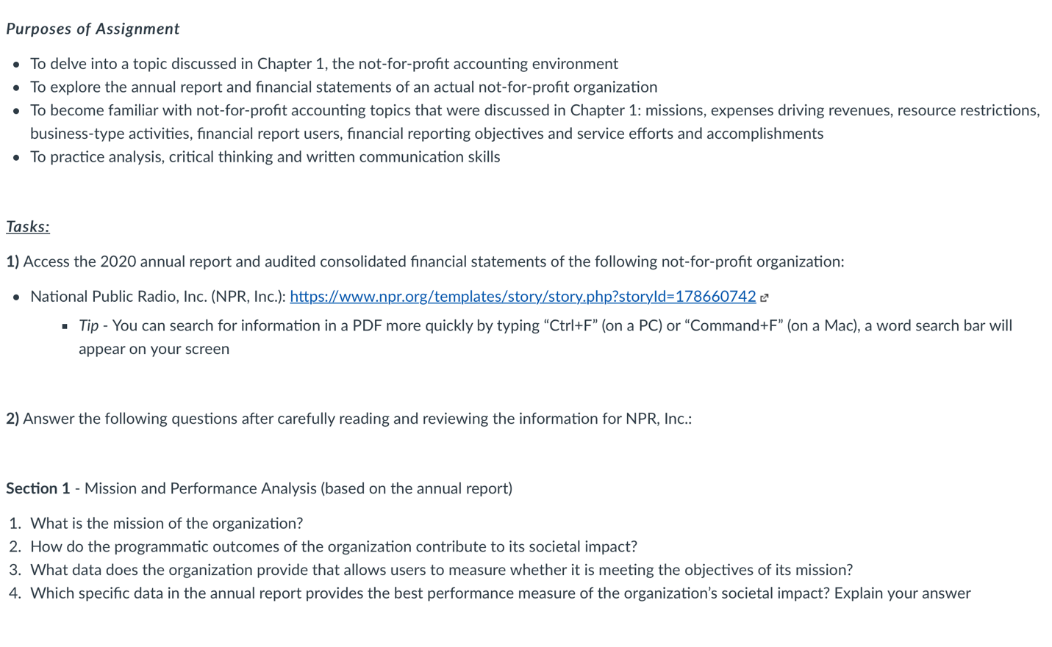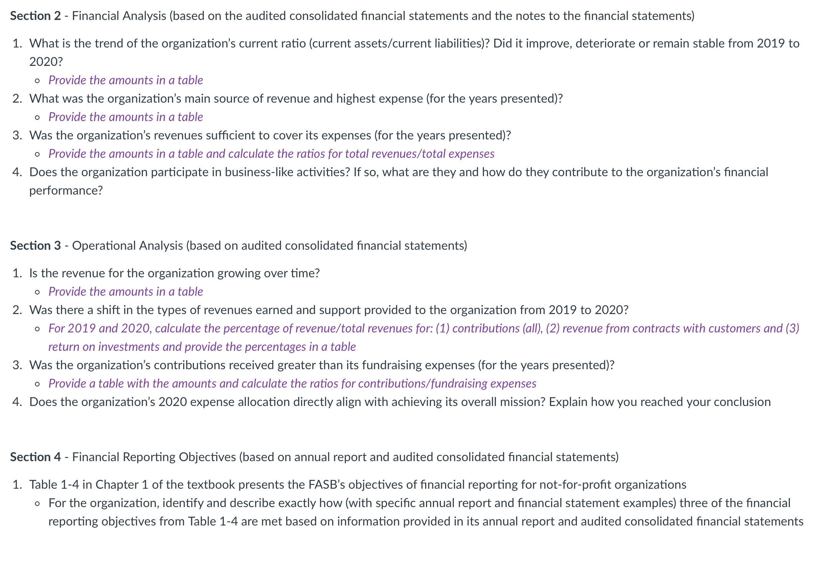

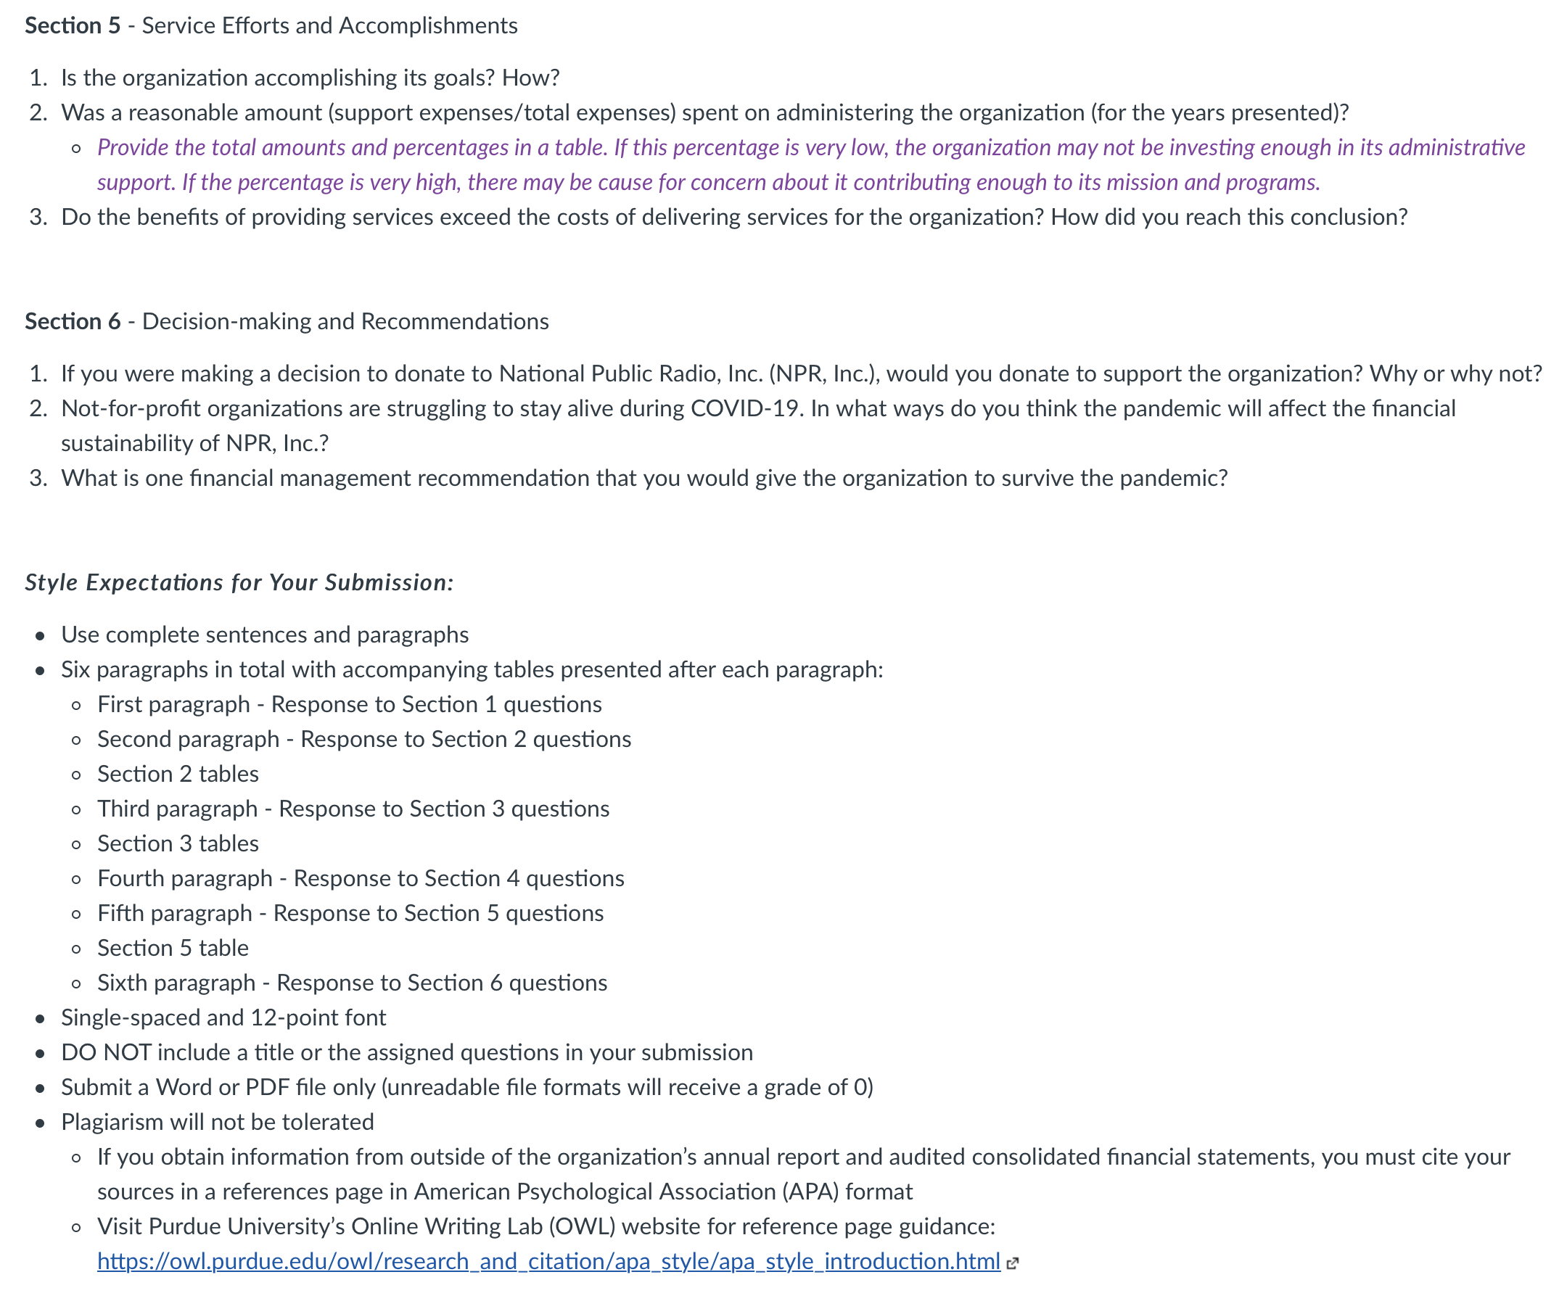

Here is a clearer picture of the assignment and instructions. Bellow is the link……

Access the 2020 annual report and audited consolidated financial statements of the following not-for-profit organization:
- National Public Radio, Inc. (NPR, Inc.): https://www.npr.org/templates/story/story.php?storyId=178660742 (Links to an external site.)

And just to clarify….

The link that is provided gives you access to the different types of information that you need to complete the case. The instructions say to access the 2020 annual report and audited consolidated financial statements. The 2020 annual report is provided in a digital format on the website and is not a PDF document. The FY2020 audited consolidated financial statements are provided as a PDF document.

The text that appears in parentheses after the Sections 1-4 assignment headings specifies whether you should use the annual report, audited consolidated financial statements or both to answer the questions.

